Schedule of Observatory Events Spring 2026
Date/Time and Information | Primary Target | Alternate Target
Feb 6th, 6:45 – 9:45 pm  Primary Object: Saturn- also known as the ringed planet, it has an average density less than water. It is almost 9 times wider than Earth. | Saturn  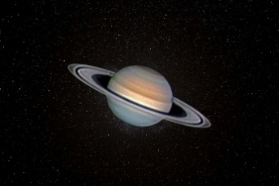 | Jupiter  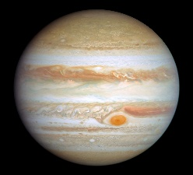
Feb 20th, 7:00 – 10:00 pm  Primary Object: Jupiter- popularly known as the king of planets, Jupiter is 11 times wider than Earth. | Jupiter | Pleiades cluster  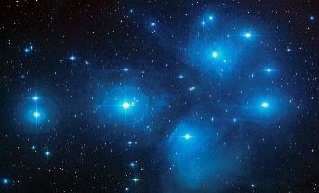
Mar 6th, 7:20 – 10:20 pm  Primary Object: The Pleiades- an open star cluster with young, hot stars. It lies 444 light years away. | Pleiades cluster | Orion nebula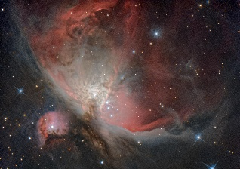
Mar 19th, 8:30 – 10:30 pm  Primary Object: The Orion Nebula- one of the closest star forming systems from us. It is about 1400 light years away. | Orion nebula  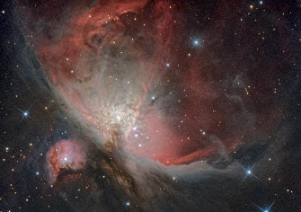 | Cigar galaxy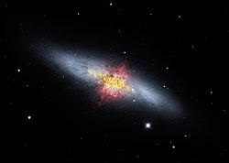
Apr 3rd, 8:45 – 11:45 pm  Primary Object: The Cigar galaxy- known for its distinct shape, it is a star burst galaxy located 12 million light years away from us. | Cigar galaxy | Beehive cluster  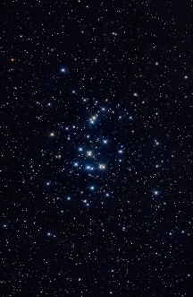
Apr 17th, 9:00 – 11:45 pm  Primary Object: Jupiter- over 1,000 Earths can fit inside it. It also has Ganymede, the largest moon in our solar system. | Jupiter | Sombrero galaxy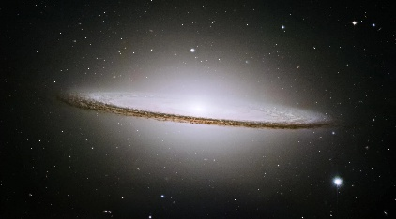
May 1st, 9:15 – 11:45 pm  Primary Object: The Sombrero Galaxy- located 30 million light years away, it is well known for its bright core and visible dust lanes. | Sombrero galaxy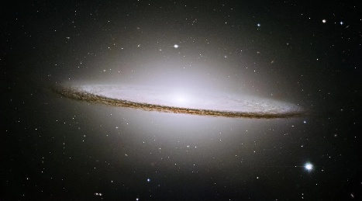 | Moon  